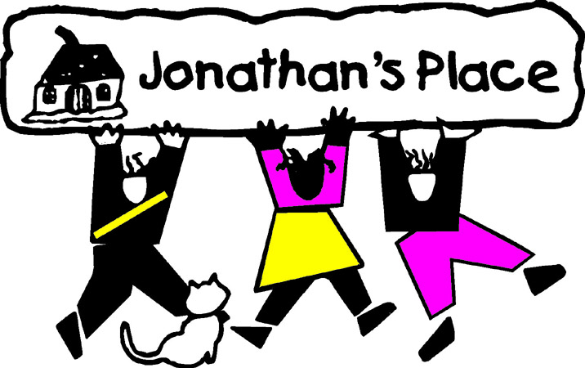
Self-Instructional Annual Training Questionnaire
Subject: Movie: While Oleander
Eligible Hours: 3

Name: __________________________________
Date Submitted: __________________________________

- What does Astrid mean that being by being with someone so dangerous she felt so safe?
- What were the Mom’s three rules never to be broken?
- How long does Child Services give Astrid to pack her belongings before taking her?
- Where is Astrid’s Dad?
- When Astrid visits her mother in prison, why does her Mom become so upset when she sees Astrid’s necklace?
- Why is Astrid put into an “RTC” (Residential Treatment Center)? Hint: The worker lists two reasons. Do you think these are good reasons to put Astrid into an RTC? Why or why not.
- When Astrid’s Mom says, “Don’t let the cattle get in the way,” what does she mean?
- Put into words Astrid’s feelings when her mom and foster mom (Claire) meet for the first time.
- Who was Annie? Why does the mother have such a difficult time discussing Annie?
- At the very end of the movie, what does Astrid mean by, “She let me go.” Please explain.

