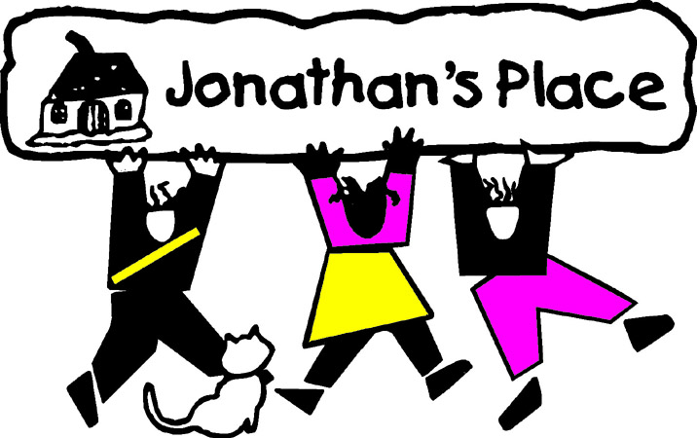
Self-Instructional Annual Training Questionnaire
Subject: Movie: Precious
Eligible Hours: 3

Name: ____________________________________________________
Date Submitted: __________________________________

- Describe Precious’ fantasies. Why do you think she has these?
- If you were in Precious’ situation (living in the home with her mother), what would you do? If you would do something different than what Precious did when living with her mother, why don’t you think Precious did things differently?
- Explain your thoughts on Ms. Rain’s encouragement to give up Abdul for adoption? Do you think this would have been the right thing to do? What if you were in Precious’ situation?
- Explain the significance of Precious placing a scarf on the young child in the Child Welfare office.
- At the end of the movie, do you think Precious made the right decision pertaining to her Mom? If you were to foster parent a girl like Precious, how would you handle your feelings towards Precious’ Mom?

