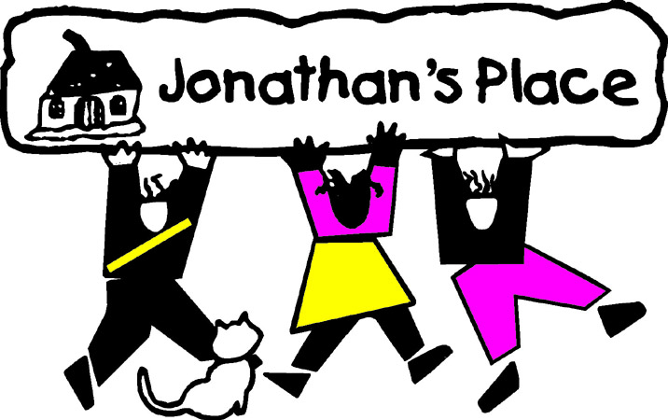
Self-Instructional Annual Training Questionnaire
Subject: Movie: Prayers for Bobby
Eligible Hours: 3

Name: ________________________________________________________
Date Submitted: __________________________________

Please answer each question in summary format. Your answers, in total, should be two (2) pages in length.

- Bobby disclosed a very big “secret” to his brother, Ed. Ed then went and told his mother because she always said to come to “them” (the parents) when there was a problem. Do you think Ed did the right thing? Who should have Bobby talked to, if anyone? If you were to suggest a method to help Bobby (at this point in the movie), what would it be?
- Explain your feelings and thoughts about Bobby’s Mom’s initial method of helping Bobby? (hanging quotes, PRAY!!!, “try harder”, …etc.) Was this right or wrong, …why?
- When the therapist asks Bobby how he knows he is “homosexual” if he has never even been sexually been with a girl, and Bobby says he just knows, what do you think he means?
- Throughout “Prayers for Bobby”, it’s made clear through words and body language that Bobby won’t change, nor will his mother. So, who wins in this situation? Does anyone? What would have been a better compromise? When thinking of a better compromise, remember both Bobby and his mother. Would both parties go for the (your) compromise?
- When Bobby’s mom speaks with the pastor of the MCC Church, she admits that she always knew Bobby was “different”. However, when kids are in foster care, they don’t always have the constant “Mom” who knows they are different. Instead, they change “Moms”, which means different viewpoints, circumstances and even how much that “Mom” knows about the foster youth, or where they come from (or how they’ve been in the past). So, does this create a problem or hardship for Lesbian, Gay, Bisexual, Transgendered or Questioning youth, which account for 20% of children/youth in out-of-home care? Explain.

