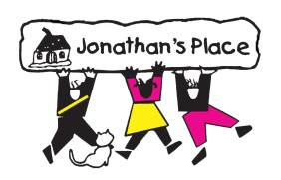
Approved OTC Medications for:

Name of Child: ______________________________________________________________________
Child’s Date of Birth: _____________________________________
Child’s Weight: _________________

Please check those that apply:
- Antibiotic Creams & Ointments for minor cuts and scratches
  - Neosporin or Store Brand Equivalent
- Hydrogen Peroxide
- Rubbing Alcohol
- Congestion Relief
  - Vicks Baby Rub
- Pain and Fever Relievers
  - Infant Ibuprofen – Dosage _______________
  - Infant Tylenol – Dosage ________________
  - Children’s Ibuprofen – Dosage ___________
  - Children’s Tylenol – Dosage ____________
  - Adult Ibuprofen – Dosage _______________
  - Adult Tylenol – Dosage _________________
- Rehydration Fluids for vomiting or diarrhea
  - Pedialyte or Store Brand equivalent
  - Gatorade or Store Brand equivalent
- Diarrhea Relief
  - Pepto-Bismol or Store Brand equivalent
- Saline Nasal drops
  - Little Noses or Store Brand Equivalent
- Skin Creams & Ointments
  - Hydrocortisone Cream (0.5%)
  - Calamine Lotion
- Topical Protectant Creams for diaper rashes
  - Desitin or Boudreaux’s Butt Paste
- Glycerin Suppositories for constipation
- Teething/Oral Treatments
  - Baby Orajel
  - Teething Tablets
  - Orajel
- Other: Please list ______________________________________________________________________________
__________________________________ __________________
Physician’s Name Date

____________________________________ __________________
Foster/Adopt Parent(s) Name Date

