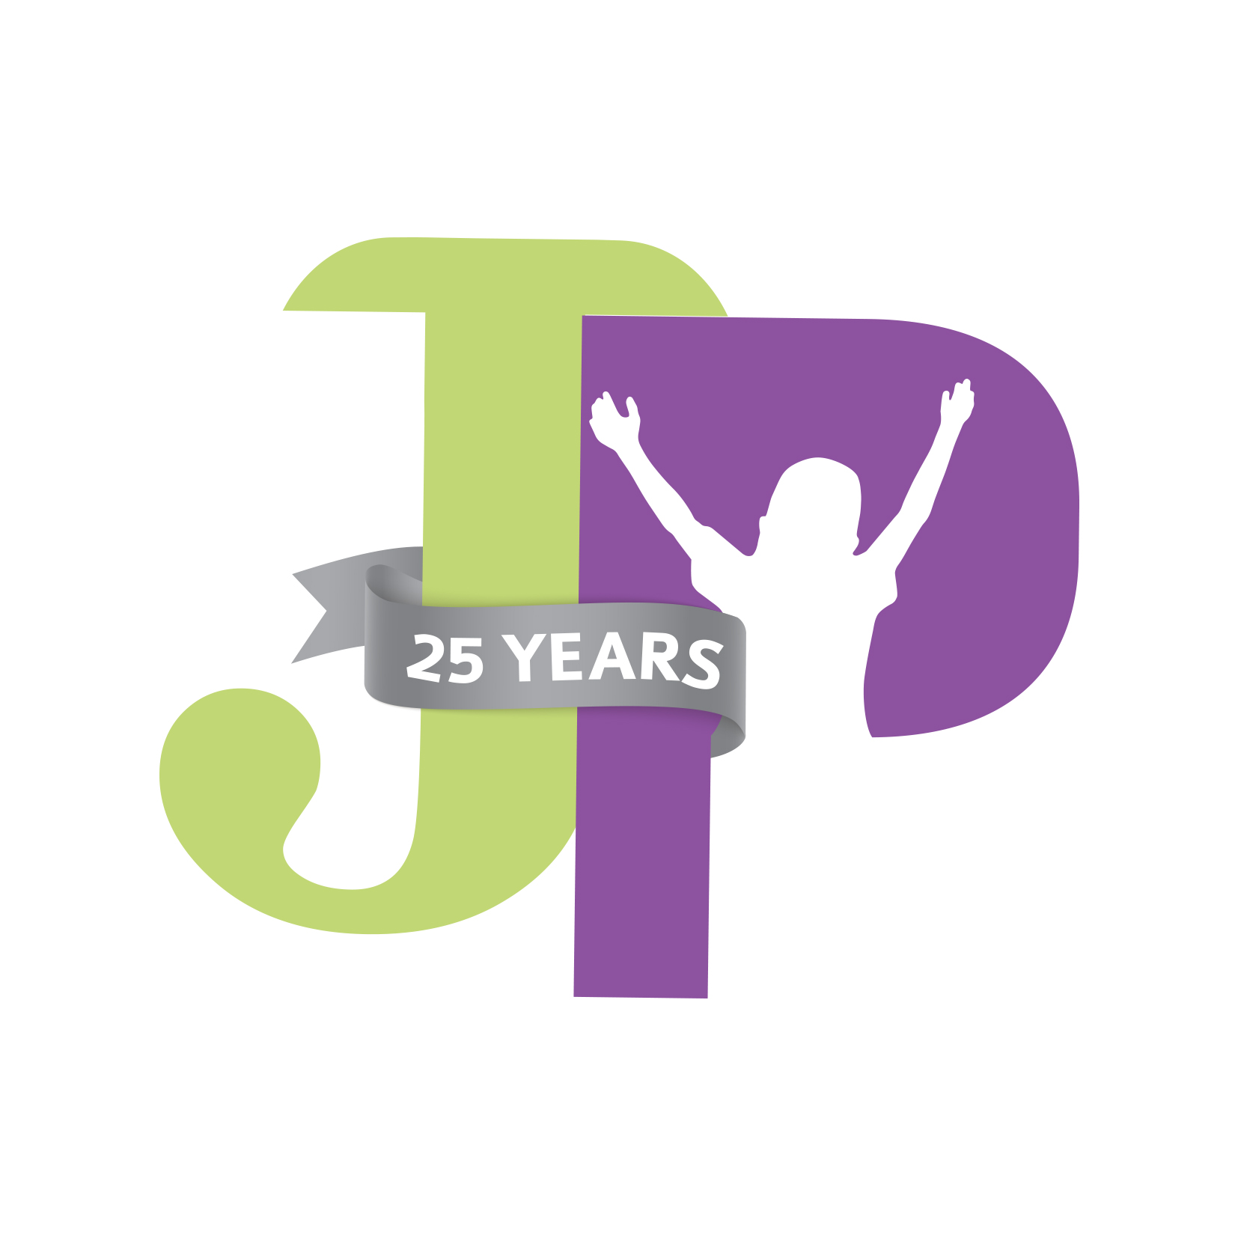
JP Cultural Competency Training

________________________________ ________________________________ Name Instructor
________________________________ ________________________________ Date Instructor's Signature
Multiple Choice
- What is cultural competency?
- A system of values and principles
- An ability to honor and respect others’ beliefs
- A method to help a group of people work together
- All the above
- What is the difference between culture and identity?
- Culture applies to an individual person, whereas identity applies to a group of people
- Culture does not include religious beliefs and customs
- Identity includes race and ethnicity
- There is no difference between culture and identity
- Who is the most accessible expert on your foster child’s culture?
- Your Jonathan’s Place case manager
- Your foster child’s birth parent
- Your foster child
- All of the above
- What is another name for the existence of a variety of cultural or ethnic groups in a community?
- Cultural diversity
- Cultural competence
- Ethnicity
- Disproportionality
- Which of the below affects the likelihood of a parent abusing or neglect a child?
- Race
- Ethnicity
- Culture
- None of the above
- What should you do when you’re confused by a tradition or belief of your foster child?
- Avoid applying your cultural norms to your foster child’s behavior
- Ask your foster child about the tradition or belief
- Inform other members of the service team about your foster children’s cultural needs
- All of the above

- What is “coming out?”
- The process through which an LGBT person accepts their own sexual or gender orientation
- The process through which an LGBT person shares their sexual or gender orientation with others
- The process through which a non-LGBT person accepts an LGBT person’s sexual or gender orientation
- Both A and B
- All the above

- What group is NOT over-represented in the child welfare system?
- Black or African American children
- LGBT children
- Hispanic/Latin@ children
- Christian children
- A person’s ethnicity is based on their:
- Food and dining customs
- Race
- Language
- All of the above

- What words can be used to describe aspects of a person’s SOGIE?
- Heterosexual
- Christian
- African American
- English

- What is one benefit of cultural diversity?

- What is confirmation bias?

II: True or False
_____13. A lack of religious beliefs is an indicator that a person may also lack good morals and values.
_____14. Gender identity is based on a person’s biology or anatomy.
_____15. People who speak the same language share the same culture.
_____16. Once you achieve cultural competence, you have it for life.
_____17. You must never make mistakes regarding the culture of a child in your care.
_____18. Foster children experience grief and a loss when they enter care, but their parents do not experience any grief or loss.

