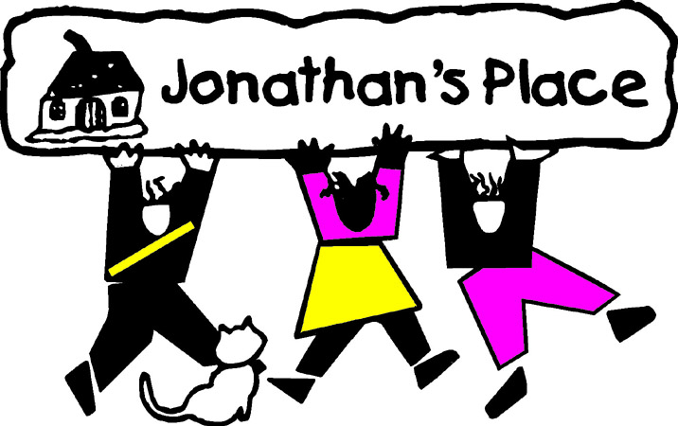
Self-Instructional Annual Training Questionnaire
Subject: Book: Hope’s Boy by Andrew Bridge
Eligible Hours: 4

Name: ____________________________________________________________
Date Submitted: __________________________________

- Both Hope, Andy’s biological mother, and Mrs. Leonard, Andy’s foster mother, had traumatic childhood backgrounds. Hope spent time in children’s homes, and Mrs. Leonard was a child survivor of a concentration camp. How might their own childhood trauma have impacted their parenting of Andy? Provide specific examples to support your conclusions.
- Were there any aspects of Hope’s relationship with Andy that were positive or beneficial for Andy? If so, what were they? If not, why not?
- Andy went to great lengths to avoid having his classmates discover he was in foster care with the Leonard family. Imagine having a discussion with a new school-aged foster child placed in your home. How would you address the child’s concerns over questions from peers about being in foster care?
- Should Andy have received more or less support for contact with his mother and grandmother? Support your conclusion.
- Should Andy’s grandmother been allowed to raise him after he was removed from Hope’s care? Support your conclusion.
- What was the most impactful aspect of the book to you? Why?

