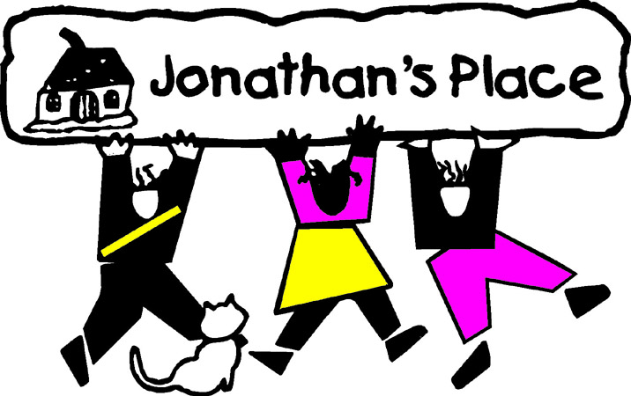
Self-Instructional Annual Training Questionnaire
Subject: Movie: The Blindside
Eligible Hours: 3

Name: _____________________________________________________
Date Submitted: __________________________________

- Explain your thoughts about the state "giving away" Michael without the consent of his mother.
- When Michael's mother talks about him, she reflects on how Michael is a "runner". Why does Michael run according to his biological mother? How does this make you feel if you were to have a foster child in the same situation?
- Do you think Michael needed to talk to a therapist? What do you think about his ability to "forget the past?"
- What did Michel test the highest in on the State test? Why? Do you think this is common with foster youth with troubled pasts?
- Explain the "Valley of Death" paper Michael wrote for school and the significance this topic had to him.
- What do you think about the NAACP view of the Michael's new family's intentions?
- What is your opinion and thoughts of a Caucasian privileged family taking in a young African American man, such as one in Michael's situation?

