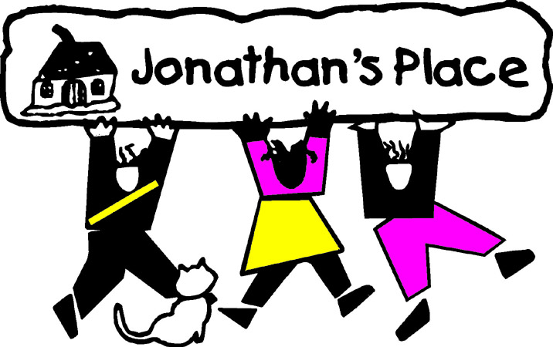
Self-Instructional Annual Training Questionnaire
Subject: Book: A Child Called “It”
Eligible Hours: 4

Name: _________________________________________________________
Date Submitted: __________________________________

Please answer each question in summary format. Your answers, in total, should be two (2) pages in length.

- Please describe the various emotions felt by Dave, including examples of each. Describe and explain some of these conflicting emotions.
- Of all of the emotions described in question one, which one do you think was most overwhelming and why? Support your answer with an example for the book.
- List the adults in Dave’s life who missed the warning signs of abuse and name the sign(s) missed. Why do you believe these signs were overlooked? Does this happen today, and if so, why? How can we avoid this?
- Describe your feelings of Dave’s Mother? How would you be able to foster/adopt Dave and respect Dave’s mother …especially around Dave? How would you support visitation between Dave and his Mother?
- Summarize parts of “A Child Called It” that impacted you. Why did these parts impact you? …explain.

